Python Programming Lab Task Sets

NAME: SARA NAUSHEN
HALL NO: 2503B05145
SET NO: 2

Set 2
- Q1. Write a Python function `is_prime(n)` to check if a number is prime. Use an AI coding tool to generate and justify a set of test cases before implementation. Pass all generated test cases.

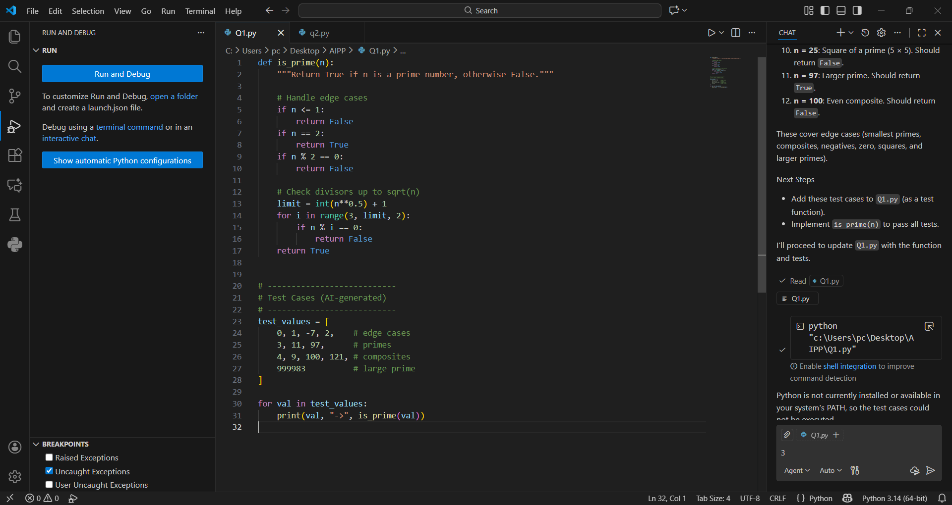

OUTPUT:

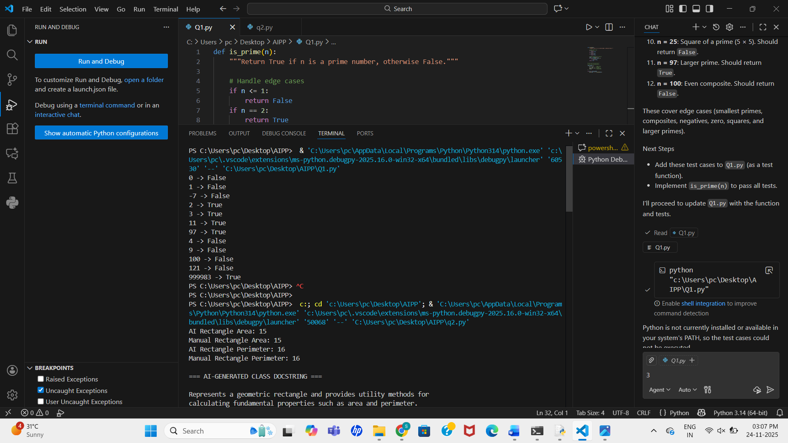

PROMPT:

- Write a Python function is_prime(n)
- Auto-generate test cases

- Q2. Develop a Python class `Rectangle` with methods for area and perimeter. Use an AI assistant for auto-generating docstrings and inline comments. Compare them with your manual documentation.

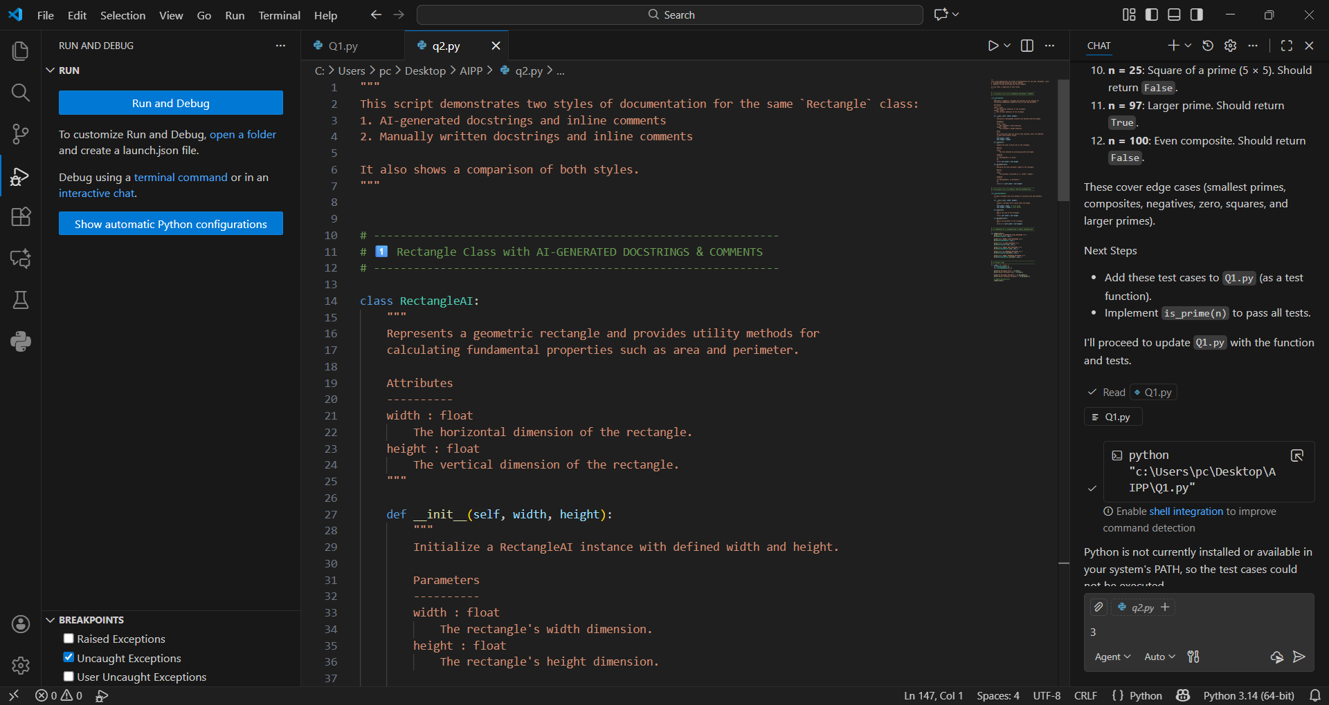

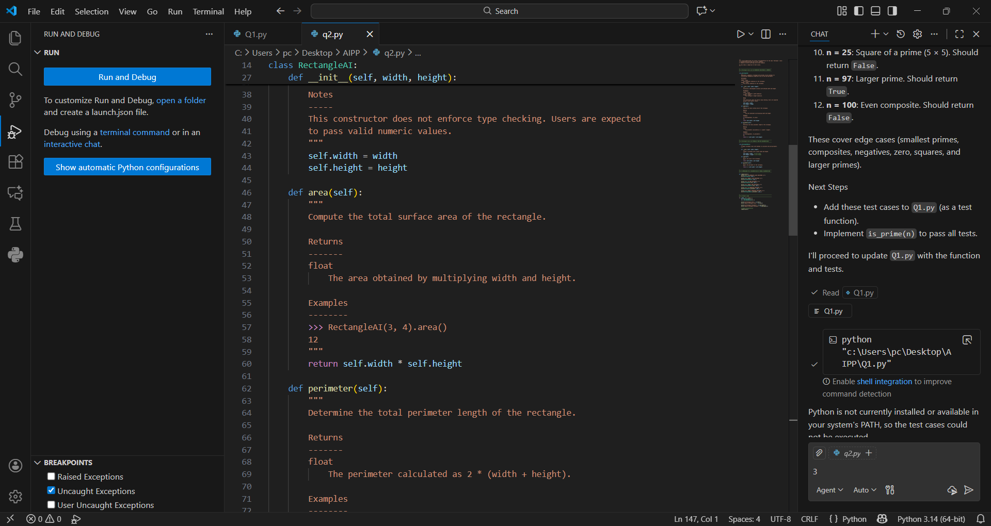

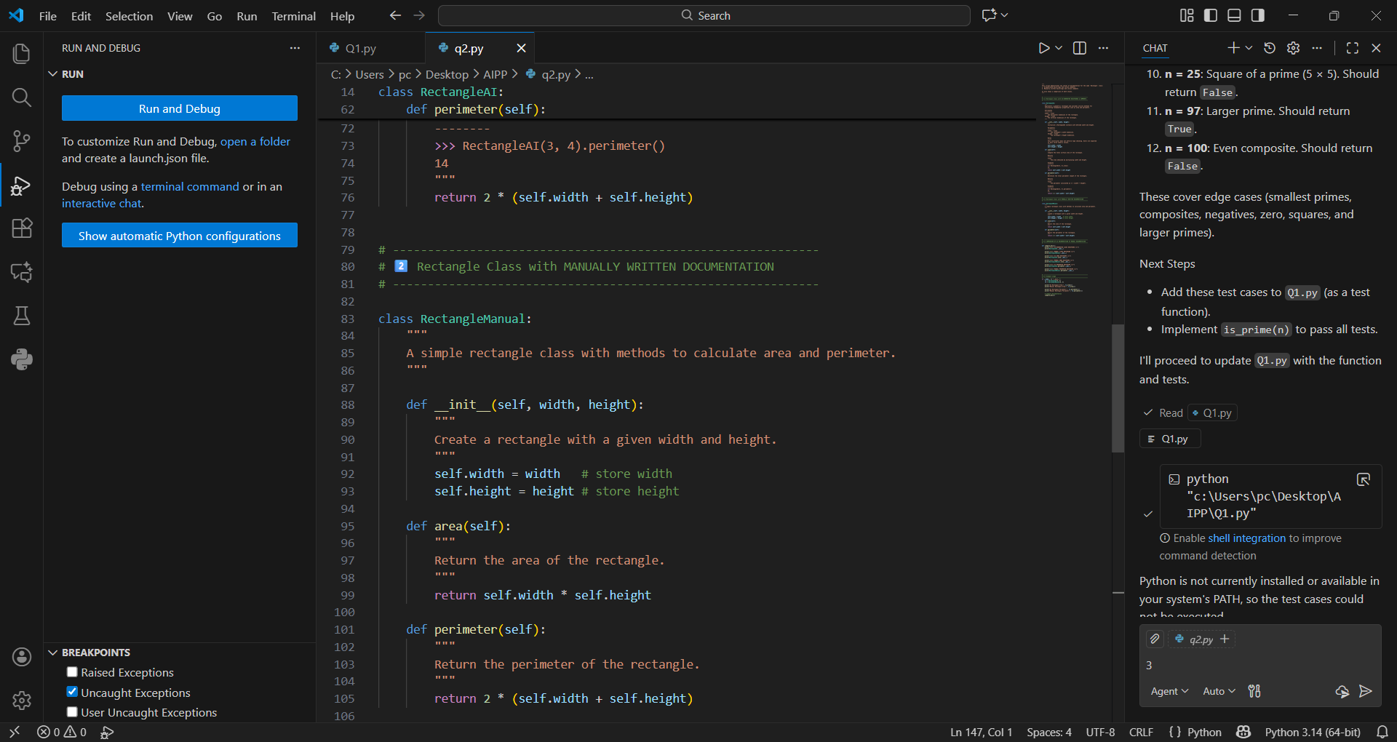

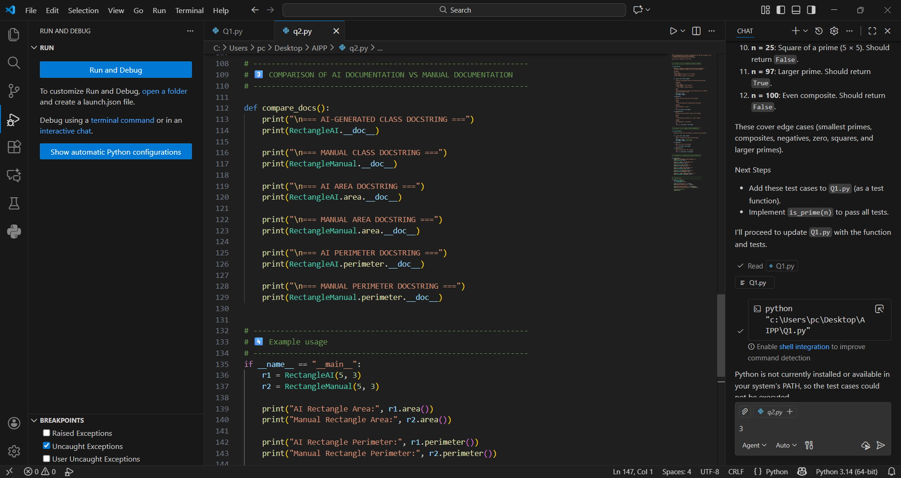

OUTPUT:
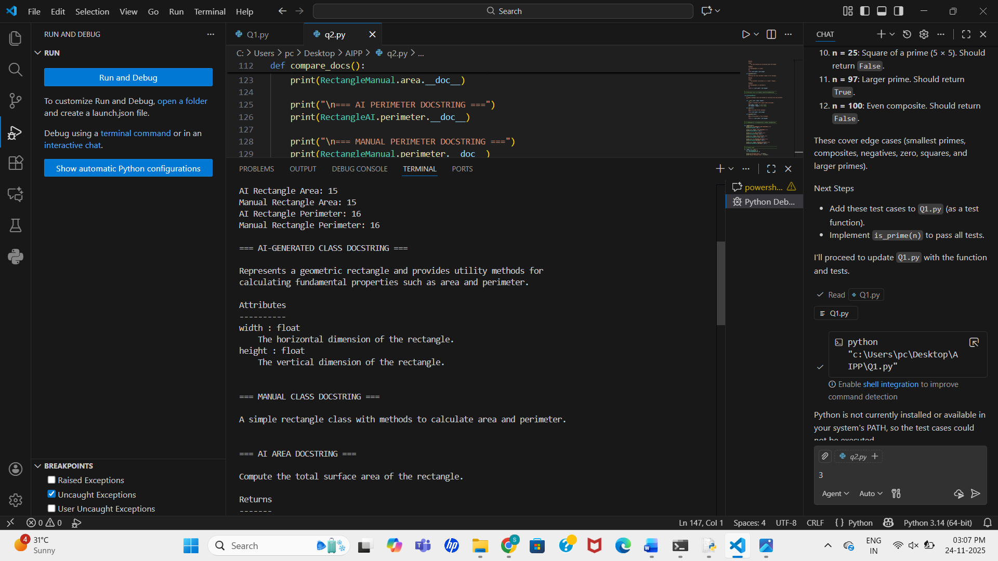
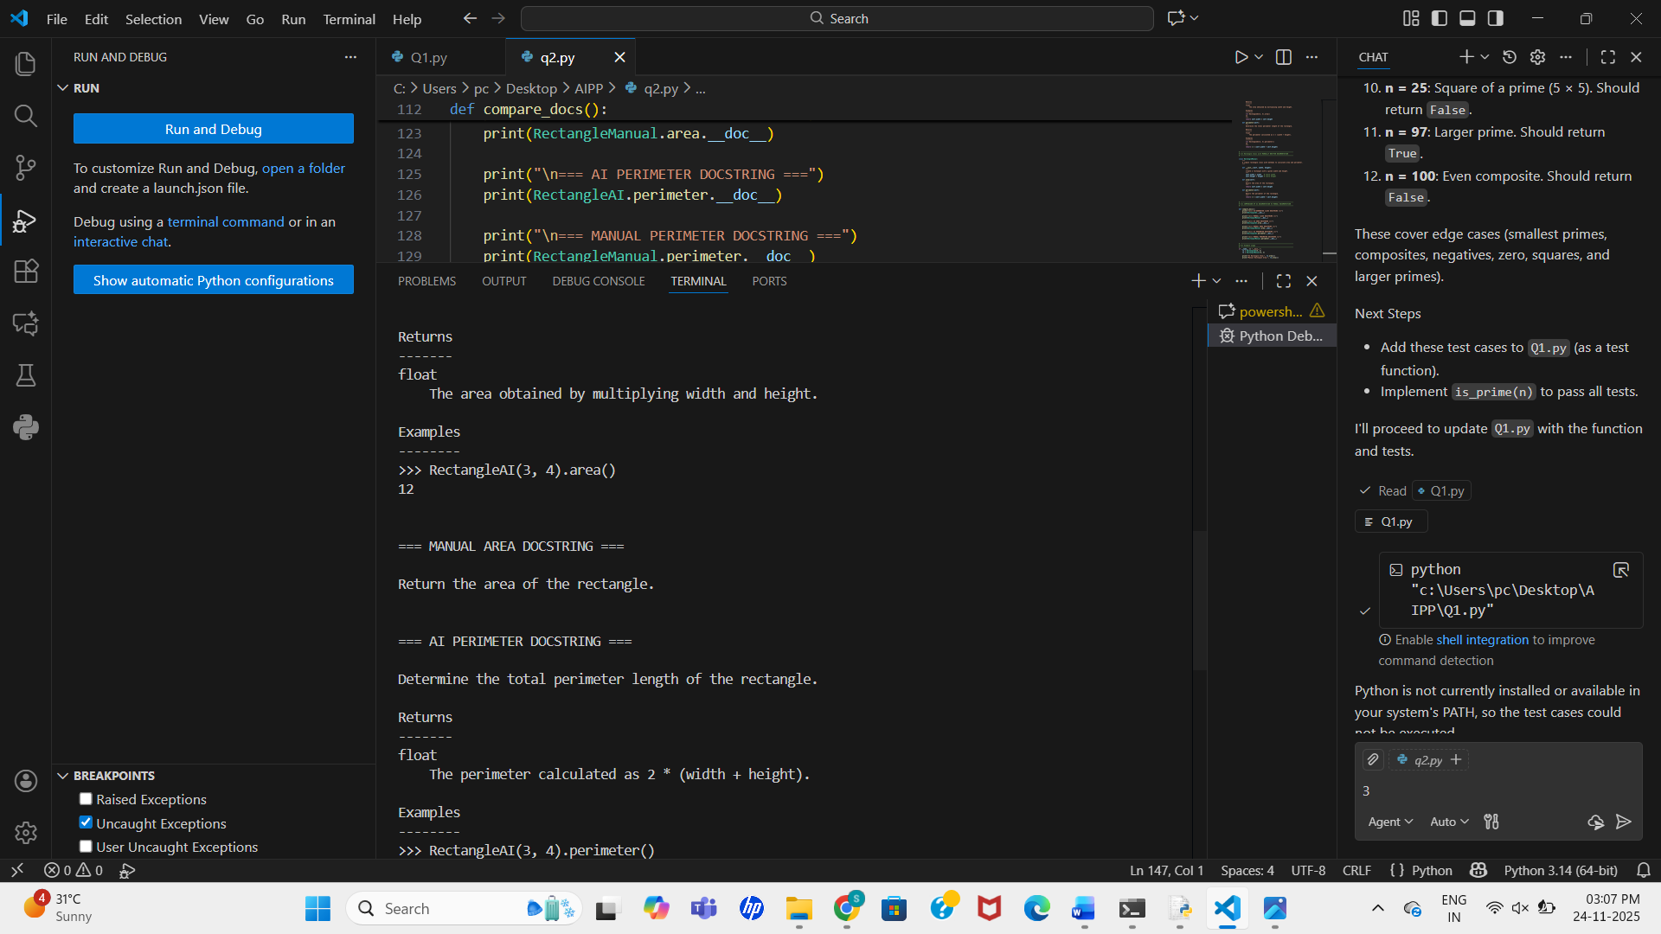
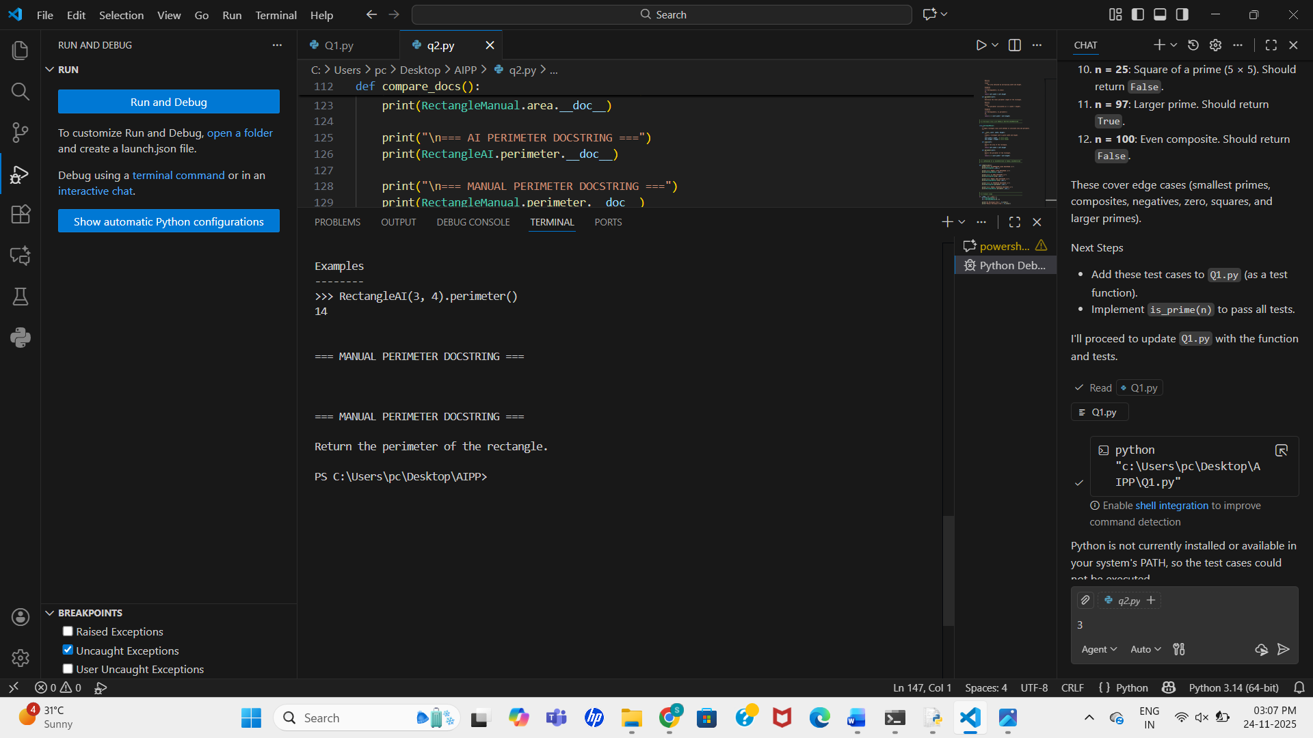
PROMPT:
- Develop a Rectangle class with AI-generated.
- Give manual docstrings.

